Crack Detection of a Reinforced Concrete (RC) Beam Specimen using SAR and GPR
Aiyad Alshimaysawee, Tzuyang Yu
Department of Civil and Environmental Engineering, University of Massachusetts Lowell
Abstract
Reinforced concrete (RC) cracking is a common problem, especially in concrete bridges. This problem is important because that the integrity of concrete cover indicates not only the mechanical strength of concrete but also the level of protection from steel corrosion. Concrete cracking and steel corrosion can occur to any component in concrete bridges. In this research project, we use remote synthetic aperture radar (SAR) and contact ground penetrating radar (GPR) to detect the surface crack in RC beam specimens. One RC beam specimen of dimensions 36”x6”x6” was cast, and a four-point bending test was carried out to generate flexural cracks in this research. Before and after cracking, SAR imaging technique scanned RC beam specimen inside an anechoic chamber at UMass Lowell at the different ranges 15cm, 30cm, and 45cm. Also, GPR sensor was used to collect range-cross range domain of RC beam specimen. From this research, we found SAR and GPR can be used for detecting a surface and location of a crack in reinforced concrete structures and because SAR and GPR use different imaging algorithms, their images appear differently when inspecting same concrete structures. Fundamentally, the scattering signal due to the presence of a subsurface crack in concrete structures is the information civil engineers can use to estimate the characteristics of a subsurface crack for condition assessment.
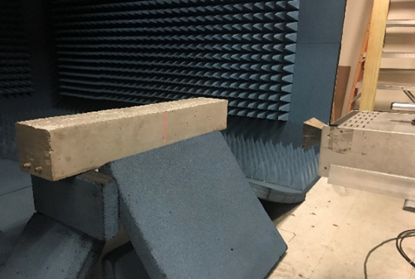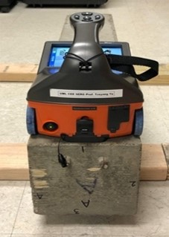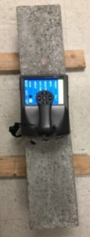
Acknowledgements: The financial support from TIDC Project 1.4 “Electromagnetic Detection and Identification of Concrete Cracking in Highway Bridges” is appreciated.

References
[1] Alzeyadi, A. and Yu, T. (2021) “Remote characterization of chloride content in oven-dried concrete specimens by using synthetic aperture radar image models,” Construction and Building Materials, 302. doi:10.1016/j.conbuildmat.2021.124317.
[2] Alzeyadi, A., T. Yu (2020), Subsurface characterization of moisture content and water-to-cement ratio of concrete specimens using remote synthetic aperture radar imaging, Journal of Applied Remote Sensing, 14 (2); 024520-1-17, doi: 10.1117/1.JRS.14.024520.
[3] Yu, T., S. Vinayaka (2020), Quantification of surface crack depth in concrete panels using 1.6 GHz GPR images, In: Proc SPIE Smart Structures/NDE, vol. 11380, April 27~May 8, doi: 10.1117/12.2558952.

