Impact of Weather Factors on Maine Lane Departure Crashes
Author: Alainie Sawtelle, Advisor: Dr. Ali Shirazi, Department of Civil and Environmental Engineering at The University of Maine
Abstract
Lane departure crashes account for over 30% of crashes and 70% of roadway fatalities in Maine. The winter season, spanning from October to April, experiences 64% of lane departure crashes despite a decrease of 18% in average daily traffic. The purpose of this study is to understand the impact of seasonal variation and monthly weather factors on lane departure crashes on rural Maine roads. This understanding will lead to improved maintenance strategies, safety, and awareness. Using monthly panel data that included average daily traffic, geometric characteristics, and weather variables, we used a Negative binomial model with GEE approach to analyze crash frequency on interstates, minor arterials, major collectors and minor collectors from 2015-2019. We modeled the winter and non-winter periods for each facility separately. Using the model estimates, a marginal effect analysis was completed. The results show that seasonal variability significantly impacts frequency of lane departure crashes. All variables including weather factors impacted frequency of crashes more during the winter period. The analysis showed that as the number of days with more than 1 inch of snowfall increases by 1% from the mean, crash frequency is expected to increase by 0.5%, 0.05%, 0.04% and 0.03% on interstates, minor arterials, major collectors and minor collectors respectively. The analysis also showed that as the number of days with more than 1 inch of rainfall increases by 1% from the mean, crash frequency is expected to increase by 0.09%, 0.02%, 0.007% and 0.01% on interstates, minor arterials, major collectors, and minor collectors respectively.

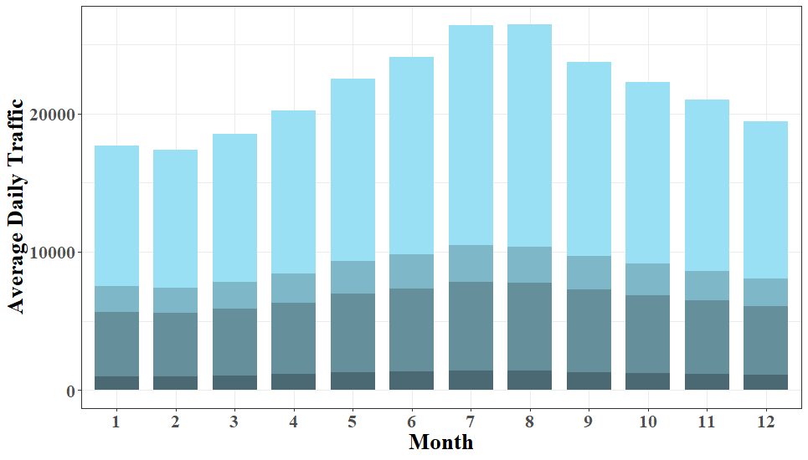 | 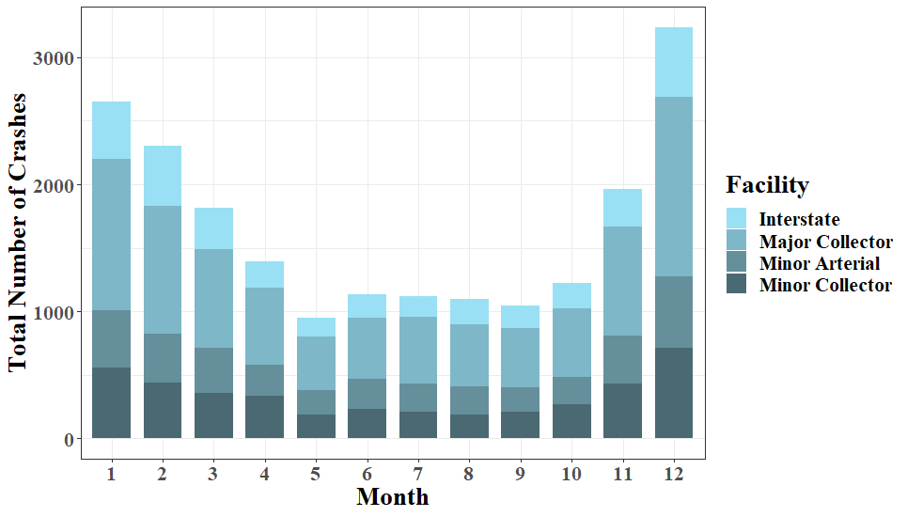
Figure shows crash counts decreasing during summer where monthly average daily traffic increases. Resulting in a need to analyze seasonal variability.

Acknowledgements: This project was financially sponsored by the Maine Department of Transportation and TIDC.

