Durability Evaluation of Carbon Fiber Composite Strands in Highway Bridges
Braedon Kohler, Keith Berube, Roberto Lopez-Anido, and Andrew Goupee
Mechanical Engineering, University of Maine
Abstract

The goal of this project is to further advance our knowledge regarding the durability of carbon fiber composite cable (CFCC) strands used in transportation infrastructure. Specifically, we aim to improve the structural health monitoring capabilities of CFCC strands placed within the stays of the Penobscot Narrows Bridge. The bridge itself is a “living laboratory” in which there are already sensors in place for two strands at six locations throughout the bridge that monitor strand response. One step of this project is to implement a wireless system to the bridge to allow the Maine Department of Transportation continuous data acquisition without having to visit the site to collect data. Bridge monitoring data will be gathered will be used to understand CFCC strand durability issues including stress relaxation in the strand or slippage of the strand anchors. A previously developed numerical simulation of the CFCC response is used to synthesize bridge monitored data and compare it to predicted performance of the cables, as shown in Figure 1. With continued monitoring and analysis of CFCC strand response in the Penobscot Narrows Bridge, greater insight into the longevity and durability of using carbon fiber composite strands in the realm of bridges and other related structures will be made.
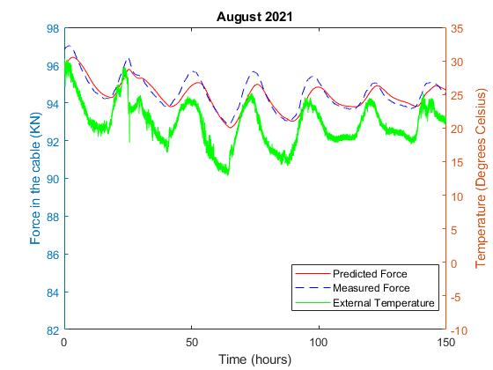
Figure 1: Predictive model of cable forces and temperature for the left cable of 10B during the week of the 20th in August
Acknowledgements: This project appreciates the help the MaineDOT has provided in facilitating access to the Penobscot Narrows Bridge.

