Durability of Large-Scale 3D Printed Materials for Transportation Infrastructure

Felipe Saavedra, Department of Civil and Environmental Engineering,
University of Maine
Advisor: Dr. Roberto Lopez-Anido
Abstract

Large-format extrusion-based polymer Additive Manufacturing (AM) or 3D printing is being used for transportation applications including culvert outlet diffusers and precast concrete formwork. This research will assess the durability and dimensional stability of thermoplastic composite material systems under different exposure conditions of moisture and freeze-thaw. Specifically, I will investigate the use of bio-based renewable polymer composites for transportation applications by correlating accelerated lab durability tests with site-specific environmental durability for selected transportation applications.
I will compare the performance of bio-based composite materials, Wood Fiber/ Polylactic Acid, (WF/PLA) with a conventional composite material Carbon Fiber/ Acrylonitrile Butadiene Styrene (CF/ABS). The durability of the material will be evaluated based on the change in flexural strength and modulus of the exposed specimens.
The research methods include selecting and adapting standard test methods for mechanical performance and durability assessment of large-format extrusion-based 3D printed materials, as well as evaluating the durability of both semicrystalline and amorphous PLA polymer systems. The environmental conditions selected are moisture exposure and freeze-thaw cycling. Digital Image Correlation with the Pontos system will be used to measure strains a displacements in flexure test. The durability assessment will be based on comparing mechanical properties and dimensional stability of conditioned and baseline specimens.
For moisture conditioning, I have implemented ASTM D5229 standard test method (See Fig. 1a). Moisture Equilibrium Content (MEC) is computed based on the sorption curve in accordance with ASTM D5229. Currently WF/PLA material specimens are being conditioned. For freeze-thaw cycling, I have implemented ASTM D7031 standard test method for Wood-Plastic Composites (WPC). The procedure consists in applying three cycles, each with moisture exposure, freezing and thawing. ASTM D7264 standard test method with a four-point bending configuration is being used to determine elastic modulus and strength in flexure (See Fig. 1b).
My future work includes specimen preparation for all 3D printed materials, conditioning, flexural tests and data analysis.

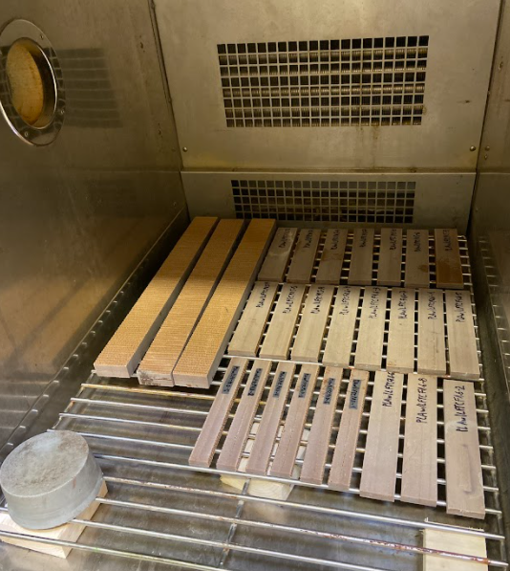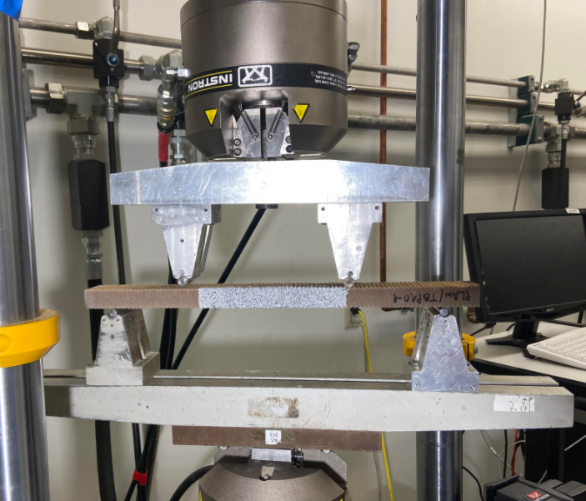
- b)
Fig. 1: a) WF/PLA specimens in Espec environmental chamber, and
b) Four-point bending mechanical test setup

Acknowledgements: This project was financially sponsored by the TIDC.

References
[1] Bhandari, S.; Lopez-Anido, R.A.; Anderson J.; Mann A., “Large-Scale Extrusion-Based 3D Printing for Highway Culver Rehabilitation”, In ANTEC 2021 Virtual Conference, SPE-Inspiring Plastics Professionals, 2021.

