Framework for prediction of accumulated bridge debris dimensions and scour
William Hughes, Qin Lu, PI: Dr. Wei Zhang, Dr. Ramesh Malla, Department of Civil and Environmental Engineering, University of Connecticut
Abstract
The accumulation of waterborne large woody debris (LWD) is a critical issue facing bridges crossing active waterways. In addition to the impact forces, drift buildup constricts flow, producing increased hydrodynamic pressures and exacerbating scour, bank erosion, and channel instability. In the United States, foundation scours from drift accumulation have been found responsible for nearly one-third of bridge failures. Accurate methods of predicting debris generation, transport, entrapment, and dimensions are consequently necessary to improve public safety, bridge designs, and informed decision-making. However, LWD generation, movement, and geometry are highly site-specific, varying with the regional tree species and hydrological, topological, geotechnical, and climatological properties. To this end, in the present study, a holistic, area-specific framework incorporating the risk assessment of local vegetation, weather, soil, and river conditions to predict debris accumulation and scour is developed. From the upstream vegetation tree species and heights, typical debris dimensions and weights are estimated using allometric relationships. Risk assessment of the riparian trees from bank instability and windthrow is conducted to obtain the probability of debris generation. The design log length and subsequent scour under storm scenarios are then computed. The framework is tested in a case study of a bridge in Vermont under the hydrological conditions imposed by Hurricane Irene in 2011. Sensitivity analysis is performed considering various debris and pier configurations. The results indicate the pier geometry is a minor factor compared to the shape of the debris. Scour depths up to five meters are predicted, indicating the bridge could be at high risk.
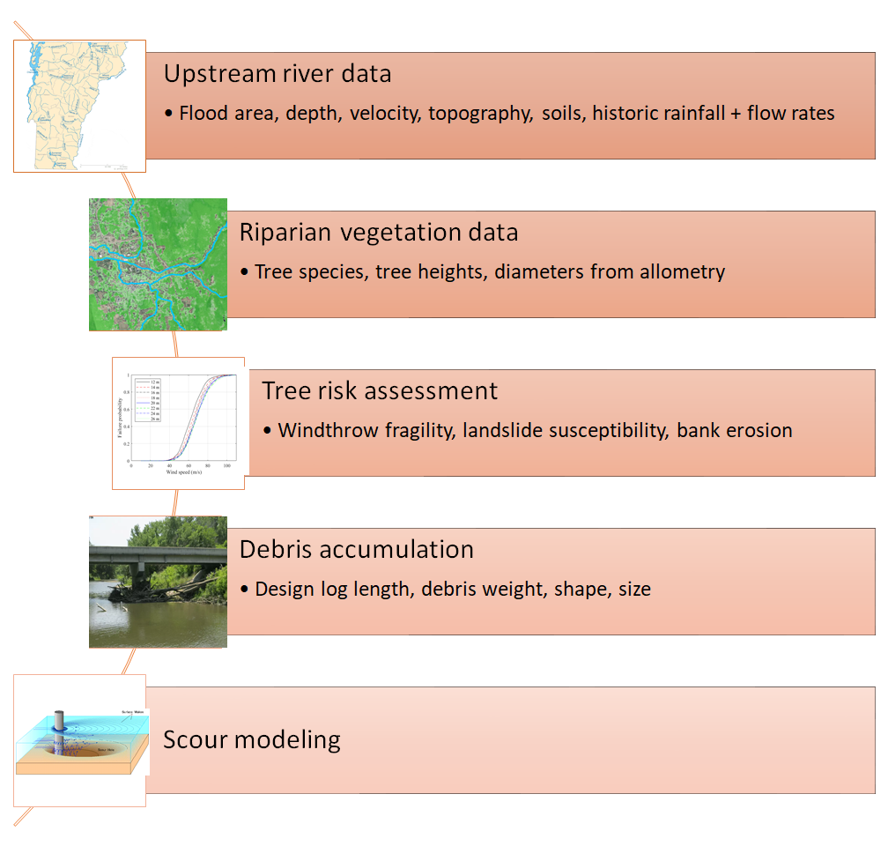
Modeling framework
Acknowledgments: The work was funded by TIDC Project C19.2020. Support and collaborations from TIDC and project technical champions (Mr. Benjamin Foster from Maine DOT and Mr. Jeffery DeGraff from VTrans) and collaborator (Mr. Andrew Mroczkowski from Connecticut DOT) are appreciated.

References
[1] Y.-M. Huang, T.-C. Lei, B.-J. Lee, and M.-H. Hsieh, “Landslide Potential Evaluation Using Fragility Curve Model,” Landslides- Investigation Monit. Ram Ray Maueizio Lazarri, IntechOpen, 2019,
[2] Q. Lu and W. Zhang, “An Integrated Damage Modeling and Assessment Framework for Overhead Power Distribution Systems Considering Tree-Failure Risks,” (Under review) 2021.
[3] E. G. McPherson, N. van Doorn, and P. J. Peper, “Urban Tree Database and Allometric Equations,” Pacific Southwest Res. Station. Gen. Tech. Rep. PSW-GTR-253, 2016.
[4] L. A. Arneson, L. W. Zevenbergen, P. F. Lagasse, and P. E. Clopper, “Evaluating Scour at Bridges. HEC-18. Fifth Edition, Hydraulic Engineering Circular No. 18. Publication,” FHWA-HIF-12-003. U.S. Dep. Transp. Fed. Highw. Adm.

