Dynamic Study of Devon Railroad Bridge Span 7th using a Laser Doppler Vibrometer
Celso Cruz de Oliveira (Ph.D. Student), Santosh Dhakal (M.S. Student), and Ramesh B. Malla, Ph.D., F. ASCE, F. EMI (Professor & Principal Investigator). Department of Civil and Environmental Engineering, University of Connecticut, Storrs, Connecticut 06269.

Abstract
Most New England railway bridges were designed and built more than a century ago using outdated material and design codes. Therefore, it is imperative to determine their current dynamic behavior due to the actual loading and vehicle type to ensure the bridge and users’ safety. This poster presents the vehicle-bridge interaction study of the span 7th of the Devon railroad bridge located in southeast Connecticut and the built-in earlier 1900s. Span 7th is a Baltimore steel truss with 66.32 meters (217’-7”) span length adjacent to the east abutment. The detailed methodology and procedure to record the field data of the typical service train using a Laser Doppler Vibrometer (figure 1) and the process to extract the dynamic parameters from data are presented and discussed. The velocity-time variation recorded from selected points can be processed and integrated to displacement time variation and Fast Flourier Transform to estimate the natural frequencies of the span. Furthermore, the Finite Element (figure 2) model is used to validate the field test results in time and frequency-domain.
With the approaching life expectance of most bridges in the United States, it is essential to establish a methodology to evaluate the existing bridges using cost-effective techniques. This project will enhance railroad bridge safety by understanding old bridges' dynamic behavior and the benefits of LDV in the bridge monitoring campaigns.

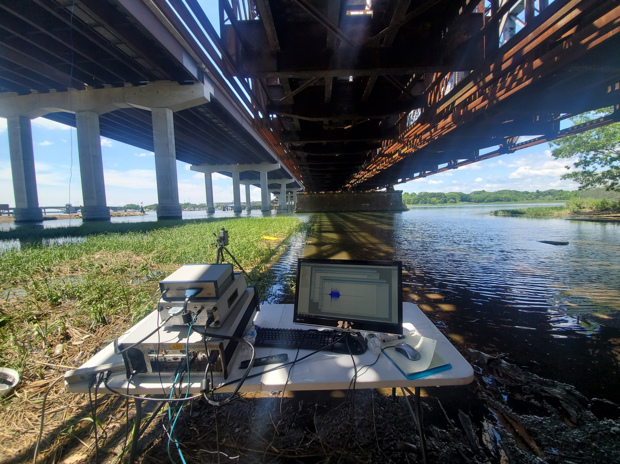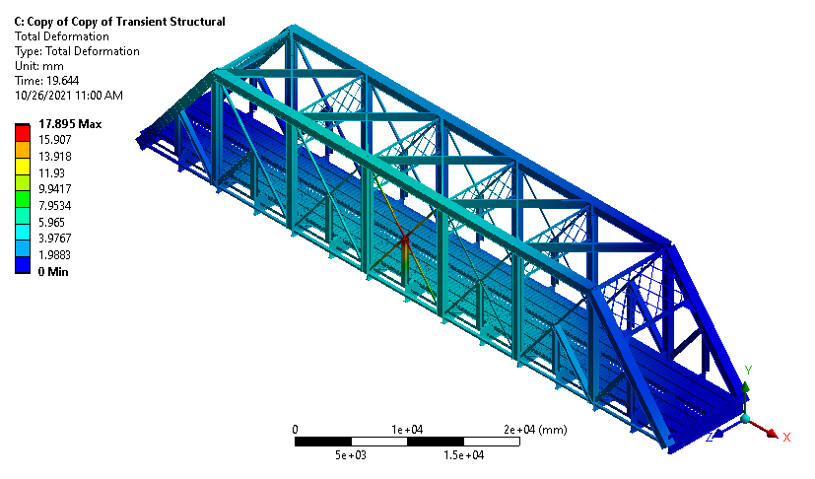
Figure 1 – Field test setup using LDV
Figure 2 - FE model of span 7th of Devon bridge
Acknowledgements: This project was partially financially sponsored by the Transportation Infrastructure Durability Center at the University of Maine under grant 69A3551847101 from the U.S. Department of Transportation’s University Transportation Centers Program.
References
[1] Malla, R. B., Jacobs, D., Dhakal, S., and Baniya, S. (2017a), “Dynamic Impact Factors on Existing Long-span Railroad Bridges,” IDEA Rail Safety Project – 25 Final Report, Transportation Research Board, Washington D.C., Feb. 2017, 40 pages. (Online http://onlinepubs.trb.org/onlinepubs/IDEA/FinalReports/Safety/Safety25.pdf).
[2] Malla, R., Baniya, S., and Jacobs, D. (2017b) “Study of Dynamic and Static Response of an Old Truss Railroad Bridge,” Procs., ASCE ASD Earth & Space 2016 Conf., ASCE, Reston, VA, Jan. 2017, 1052-1062.
[3] Jorge Fernández Heredero, 3D Vibration Measurement using LSV. Original paper presented at AdMet 2012.February 2012.

