Tensile properties of Two Old Railroad Steel Bridges in Connecticut
Santosh Dhakal (M.S. Student), Celso Cruz de Oliveira (Ph.D. Student), and Ramesh B. Malla, Ph.D., F. ASCE, F. EMI (Professor & Principal Investigator). Department of Civil and Environmental Engineering, University of Connecticut, Storrs, Connecticut 06269

Abstract
Most of the railroad bridges in service in the New England area were built more than a century ago using ASTM A7 steel, which was later withdrawn and replaced by ASTM A36 in 1967. So, it is imperative to understand the mechanical behavior of such outdated material to avoid any possible catastrophic failure.
Here we present the tensile properties of the critical members from the Devon and the Cos Cob bridges obtained from the tensile test (monotonic loading to failure). Thus obtained results are compared to the predefined values in ASTM A7-39 specifications and the results in the report published by the Fritz laboratory. The comparison shows that the results are closely related.
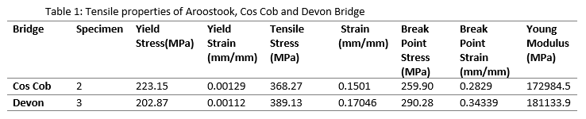

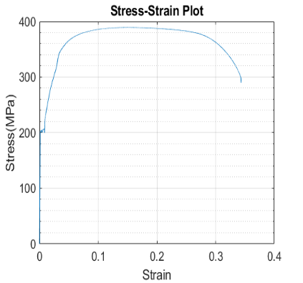
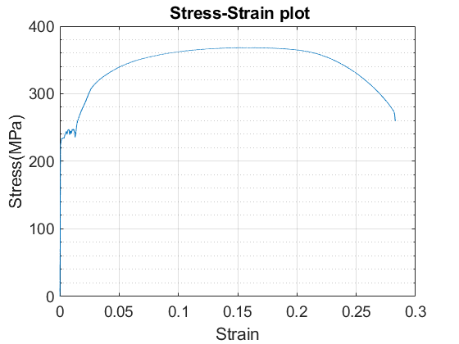

Figure 1: Tensile test result (Cos Cob Bridge, CT) Figure 2: Tensile test result (Devon Bridge CT)
Acknowledgements: This project was partially financially sponsored by the Transportation Infrastructure Durability Center at the University of Maine under grant 69A3551847101 from the U.S. Department of Transportation’s University Transportation Centers Program. The research team is thankful to ConnDOT and Metro North Railway for their continuous support throughout the research.
References
ASTM A7-39. (1939). Standard Specifications for STEEL FOR BRIDGES AND BUILDINGS’.
Nagaraja, Rao, N. R., "Material properties of structural carbon and high strength steels, August 1963" (1963).Fritz Laboratory Report. Paper 1681.http://preserve.lehigh.edu/engr-civil-environmental-fritz-lab-reports/1681

