Improved Bridge Capacity Assessment by Nonlinear Proxy Finite-Element Analysis
Andrew Schanck, E.I., William Davids, Ph.D., P.E.: UMaine Civil and Environmental Engineering
Abstract

Older, reinforced concrete T-beam bridges are often found structurally deficient for modern loading, despite carrying modern service loads without obvious damage. Ten T-beam bridges were instrumented and field load tested using heavy trucks revealing, that each had additional live-load capacity above that predicted by conventional analysis. However, linear extrapolation of test results was not able to demonstrate the adequacy of all of the bridges for modern ultimate-level loading. To better assess the capacities of these and other bridges, taking into material nonlinearity and system-behavior, a novel, nonlinear proxy finite element analysis (PFEA) technique was developed. This technique allows computationally efficient prediction of bridge response up to failure, while accounting for the ductility and load redistribution present in the actual structures. PFEA uses nonlinear optimization to tune the constitutive behavior of a shell-element discretization of each girder such that its moment-curvature response becomes equivalent to that of the solid reinforced concrete T-beam sections. The resulting elastic and elastic-plastic shell-element discretization is straightforward to implement in a three-dimensional model of a complete bridge using commercial finite element software. Using PFEA, the ten field-tested bridges were analyzed, and the capacities of each were predicted to be greater than those calculated by either conventional analysis or field-testing. PFEA has also been used to consider skew effects and rating bridge’s shear capacities, and was extended to handle the effects of prestressing, which was verified with the results of a full-scale failure test of a prestressed concrete girder bridge reported in the literature.

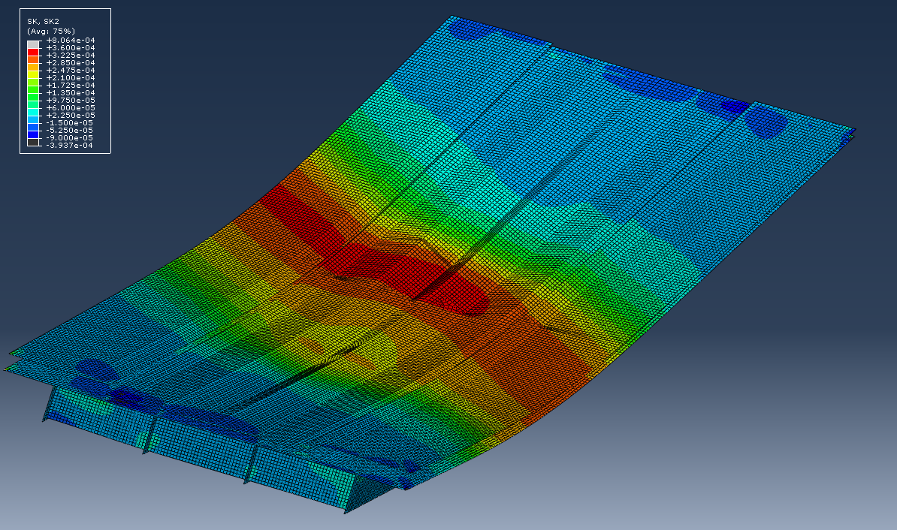

Acknowledgements: This research was funded in part by the Maine Department of Transportation.

