ASSESSMENT OF MICROPILE-SUPPORTED INTEGRAL ABUTMENT BRIDGES
Author: Sebastian Montoya-Vargas, Advisors: Aaron Gallant & William G. Davids, Department of Civil and Environmental Engineering, University of Maine
Abstract

Integral abutment bridges (IABs) are the preferred bridge type utilized by the Maine Department of Transportation (MaineDOT) and other transportation agencies throughout the United States due to their durability and reduced upfront and life-cycle costs. Shallow bedrock and challenging subsurface conditions (e.g. cobbles, boulders, etc.) commonly encountered in Maine preclude the use of conventional driven pile foundations in some instances. Micropiles are small diameter drilled foundation elements that can penetrate hard foundation materials and obstructions to facilitate IAB construction. Though micropiles can develop high geotechnical resistances in tension and compression, due to their smaller cross-section and flexural weakness at the threaded joints of steel casing segments, allowable IAB span lengths may be governed by the bending capacity of micropiles commonly available.

This study assesses the structural capacity and applicable span lengths for micropile-supported IABs. The relative influence of bridge geometry and subsurface conditions influencing loads imposed on these elements, and uncertainties regarding the flexural weakness at threaded connections. 3D Finite Element Analyses (FEA) were performed to investigate the structural loads and bending imposed for a broad range of a.) micropile types, b.) IAB span lengths, and c.) soil profiles. Design guidance regarding the structural capacity of micropiles supporting IABs is discussed.

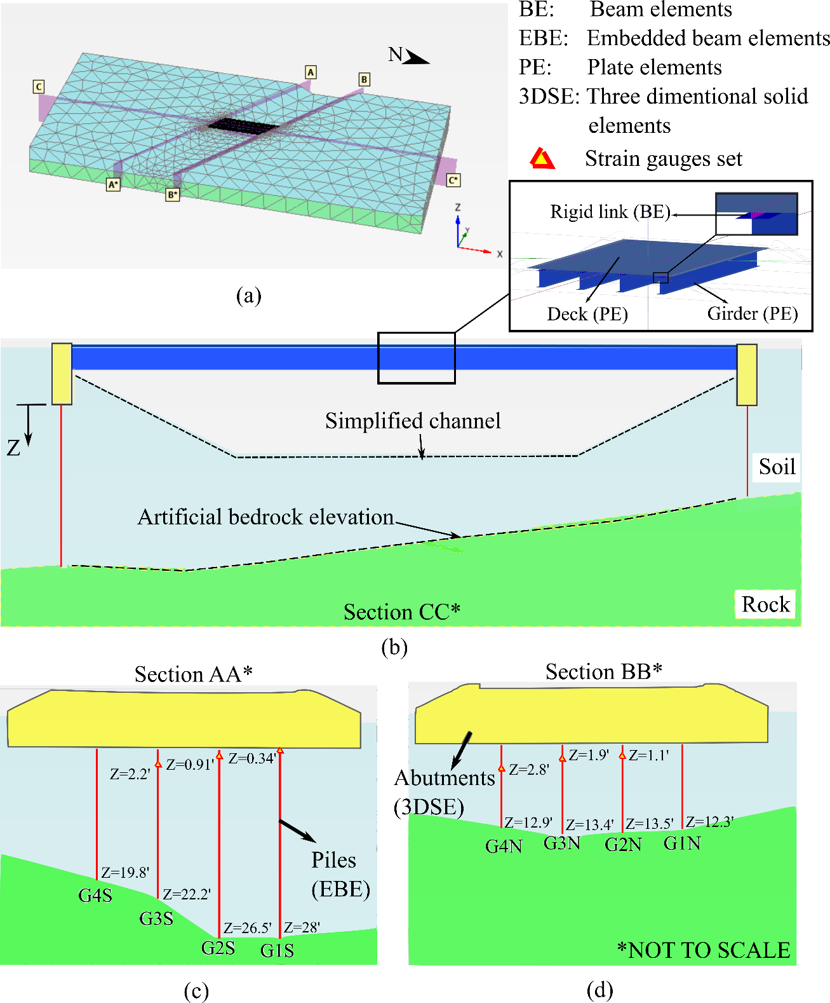
Figure 1. Finite Element Model: (a) Finite element mesh and element types; (b) Simplified soil profile and structural elements; (c) South abutment; (d) North abutment.

Acknowledgements: The financial support from the Maine Department of Transportation (MaineDOT) and assistance and advice of Mr. Dale Peabody, Laura Krusinski, and Garrett Gustafson of the MaineDOT is sincerely appreciated. Additional support provided by the Transportation Infrastructure Durability Center at University of Maine under grant 69A3551847101 from the U.S. Department of Transportation University Transportation Center Program is also greatly appreciated.

